Active Students forecast
Investigating the trends
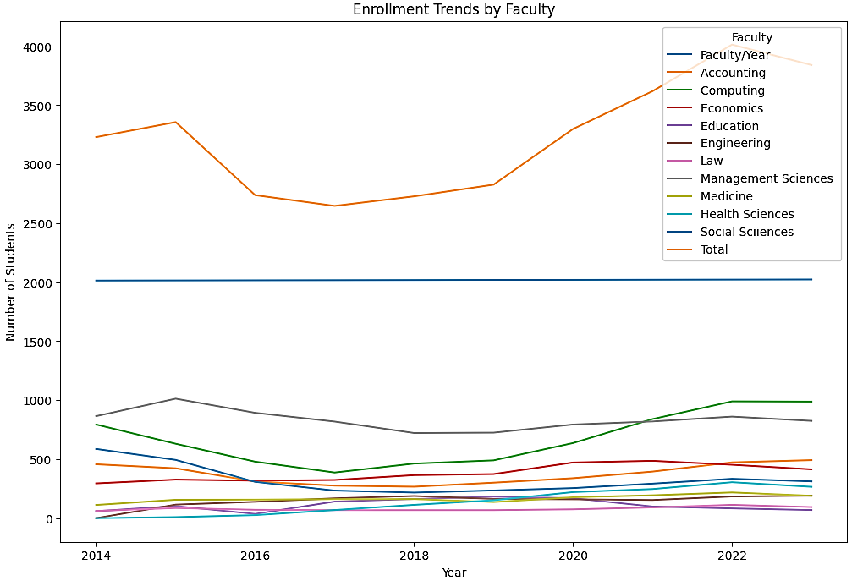

1. Overall active undergrad students
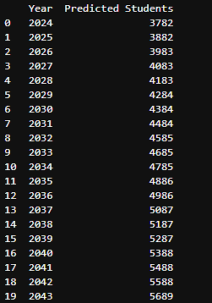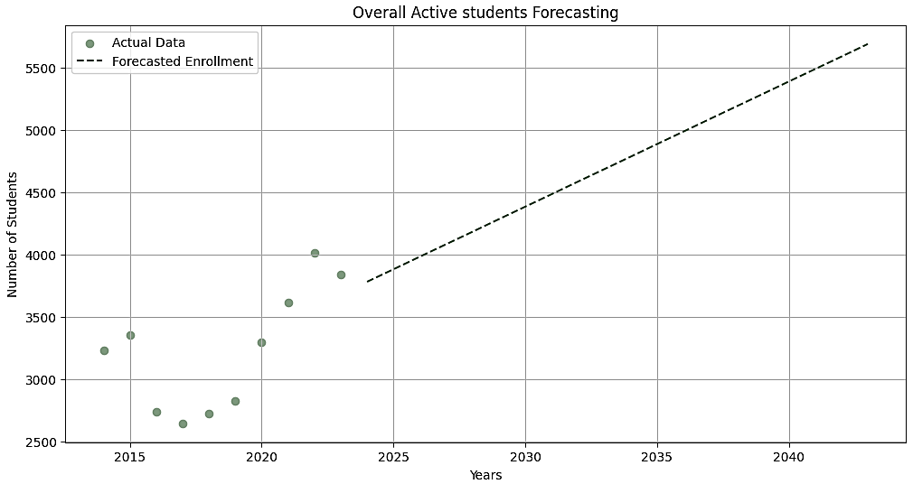
The Overall undergrad students show an overall increase starting from around 3230 actual students in 2023 to 5689 projected students in 2043.
2. All master programs
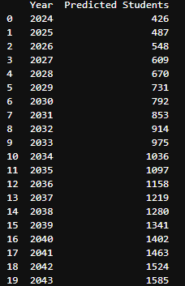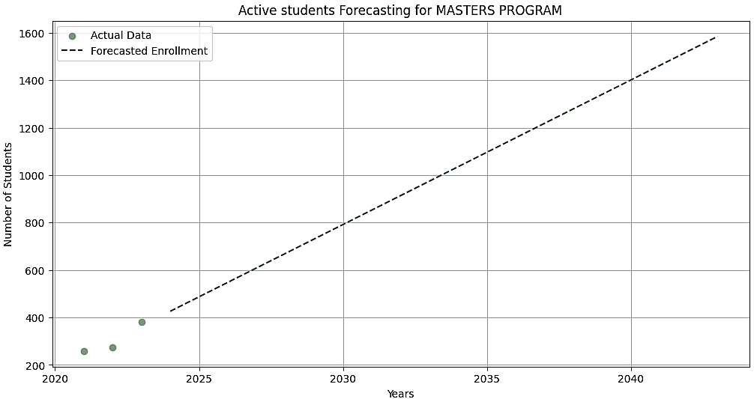
The Master programs show an overall increase starting from around 381 actual students in 2023 to 1585 projected students in 2043.

3. Faculty of Accountancy
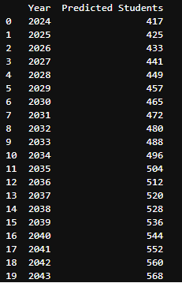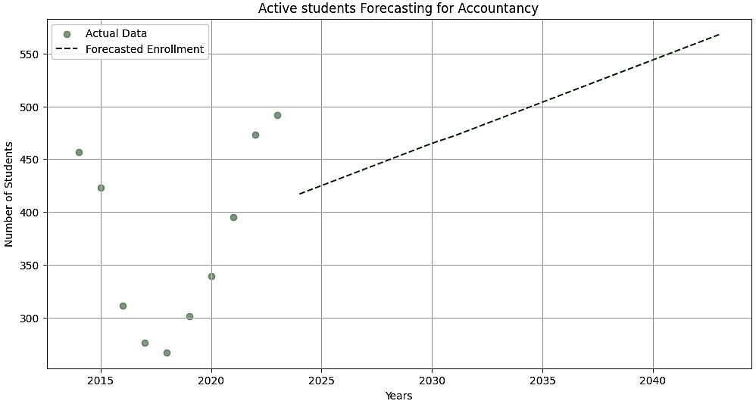
The Faculty of Accountancy programs show an overall increase starting from around 492 actual students in 2023 to 1585 projected students in 2043.
4. Faculty of Computing
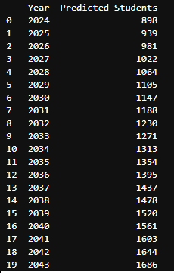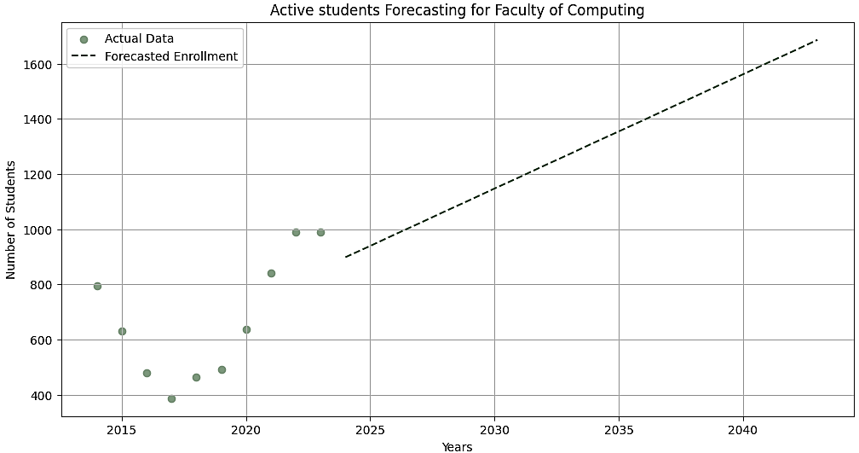
The Faculty of Computing programs show an overall increase starting from around 988 actual students in 2023 to 1686 projected students in 2043.

5. Faculty of Economics
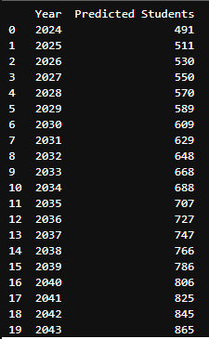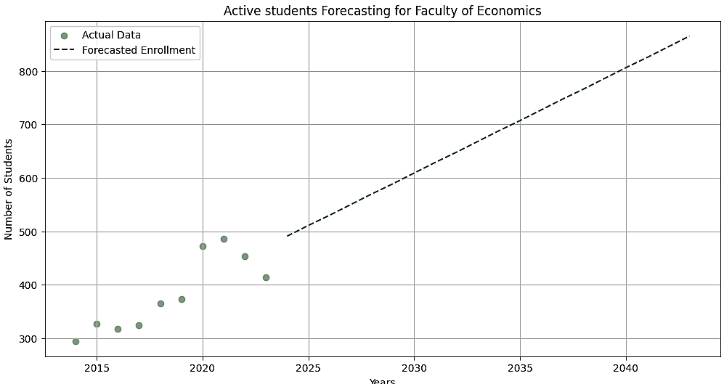
The Faculty of Economics programs show an overall increasing trend starting from around 414 actual students in 2023 to 865 projected students in 2043.
6. Faculty of Education
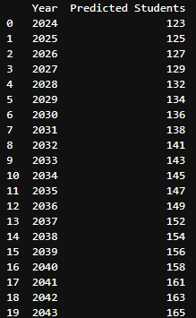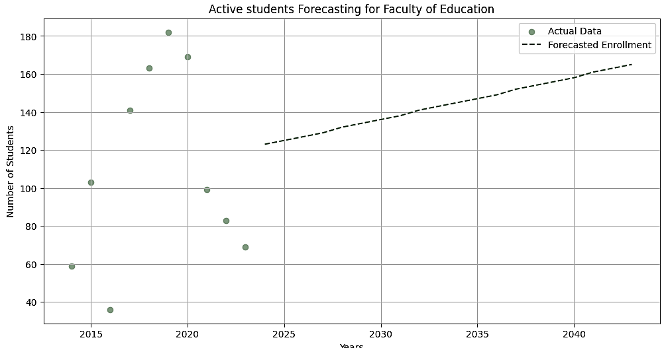
The Faculty of Education shows an overall increasing trend starting from around 69 actual students in 2023 to 165 projected students in 2043.

7. Faculty of Engineering
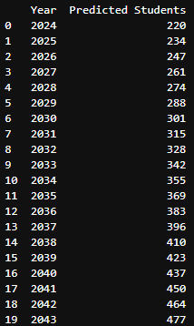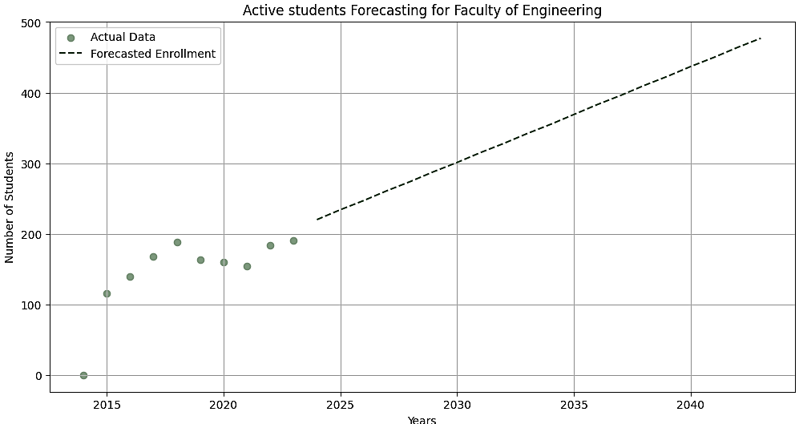
The Faculty of Engineering shows an overall increasing trend starting from around 191 actual students in 2023 to 477 projected students in 2043.
8. Faculty of Management Science
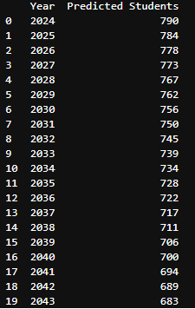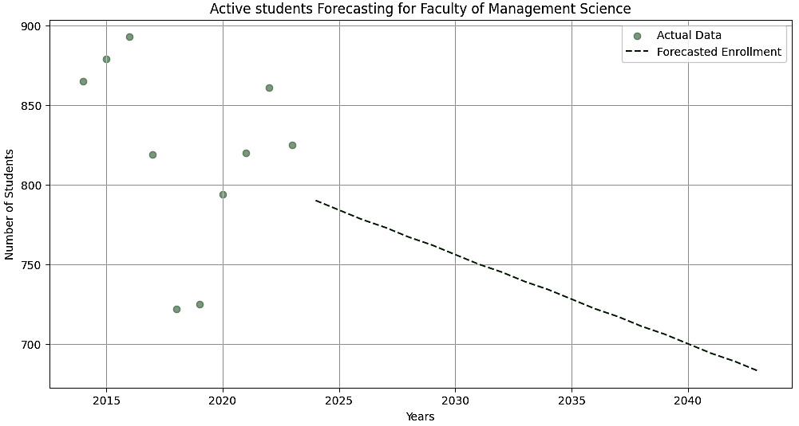
The Faculty of Management Science shows an overall decreasing trend starting from around 825 actual students in 2023 to 683 projected students in 2043.

9. Faculty of Social Science
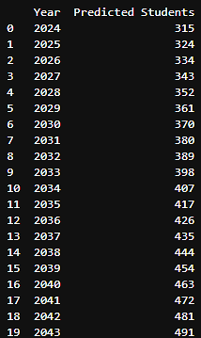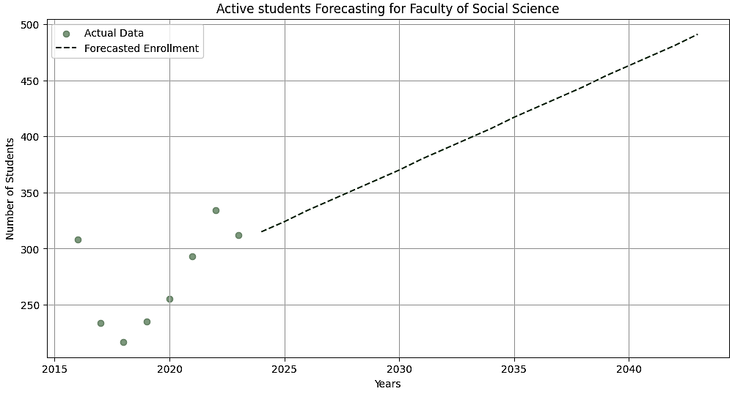
The Faculty of Social Science shows an overall increasing trend starting from around 312 actual students in 2023 to 491 projected students in 2043.
10. Faculty of Law
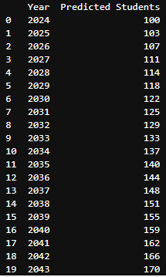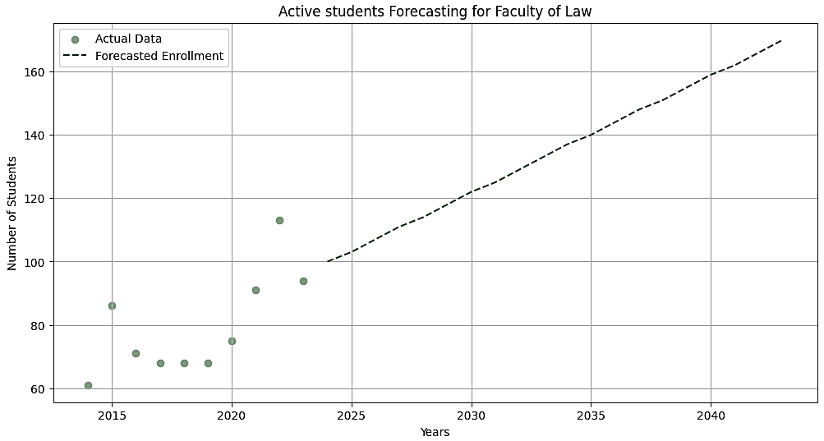
The Faculty of Social Science shows an overall increasing trend starting from around 94 actual students in 2023 to 170 projected students in 2043.

11. Medicine and Surgery program
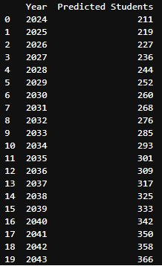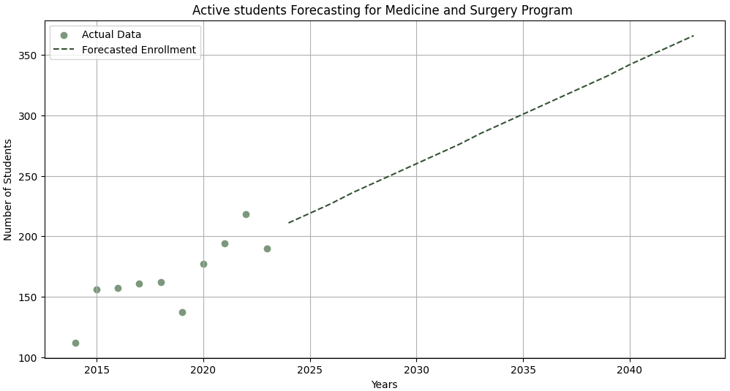
The Faculty of Medicine and Surgery program shows an overall increasing trend starting from around 190 actual students in 2023 to 366 projected students in 2043.

12. Health Science
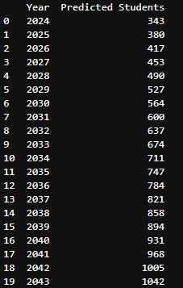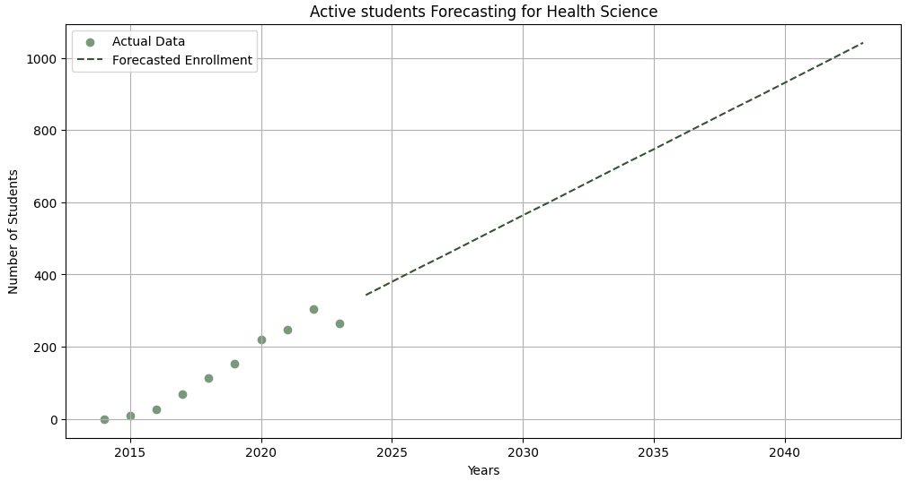
The Faculty of Health and Science program shows an overall increasing trend starting from around 266 actual students in 2023 to 1042 projected students in 2043.

Conclusion:
Based on the trend and analysis, the departments can be classified in following three categories:
1. Upward Trend
- The overall undergrad active students have shown upward trend, with number of students in 2023 to be 3841 and then predicted students in 2043 will be 5689, showing average annual growth of about 2.41% per year.
- The medicine and surgery program has shown upward trend, with number of students in 2023 to be 190 and then predicted students in 2043 will be 366, showing average annual growth of about 4.63% per year.
- The master’s program has shown upward trend, with number of students in 2023 to be 381 and then predicted students in 2043 will be 1585, showing average annual growth of about 15.80% per year.
2. Downward Trend
- The Faculty of Management Science has shown downward trend with number of students in 2023 to be 825 and then predicted students in 2043 will be 683, showing an annual decline rate of
about -0.86% per year

